**1** The graph shows the number of blood donors with different blood groups.

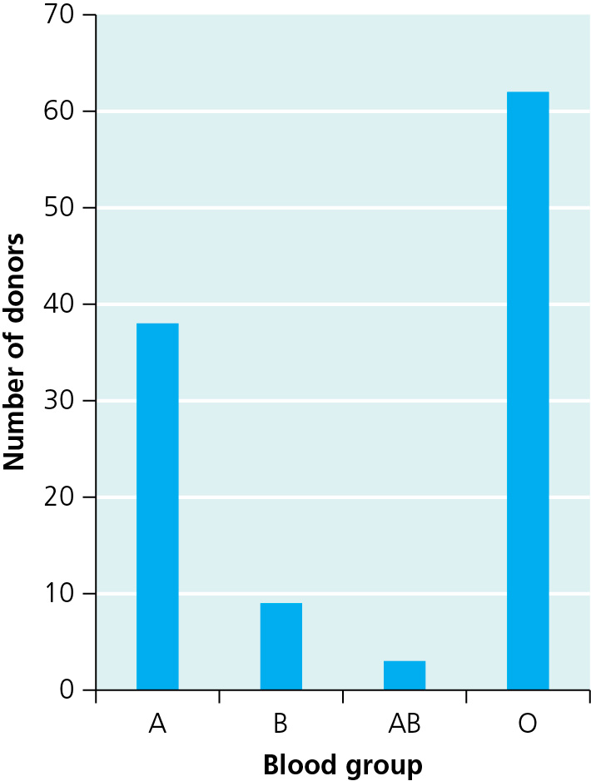

**a)** Which is the most common blood group? (1)

**b)** How are blood groups inherited? (1)

**c)** What type of variation is shown by the graph? (1)

**d)** What type of graph is this? (1)

The graph below shows how another type of variation can be represented.

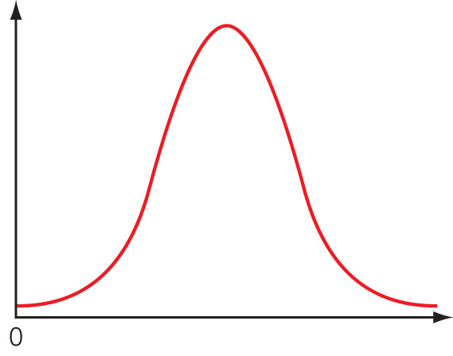

**e)** What type of variation is show by this shape of graph? (1)

**f)** What causes this type of variation? (2)

**g)** What is the name given to this shape of graph? (1)

**2** Write down the correct technical term or terms for the descriptions on bioengineering.

**a)** An organism that is a mixture of genes from two or more different species. (1)

**b)** The technique of moving genes from one organism to another. (1)

**c)** An organism that has had its genes changed. (1)

**d)** Asexual reproduction to create genetically identical organisms. (1)

**e)** A loop of DNA that can be used to transfer genes from one organism to another. (1)

**3** Vitamin A is essential for good eyesight and it is found in the orange pigment carotene. Rice does not naturally contain any vitamin A. Some people have a diet which is mainly rice. These people do not get enough vitamin A and have problems with their vision. Golden rice has now been developed by scientists. Golden rice contains carotene. The stages in the engineering of golden rice are shown in the diagram.

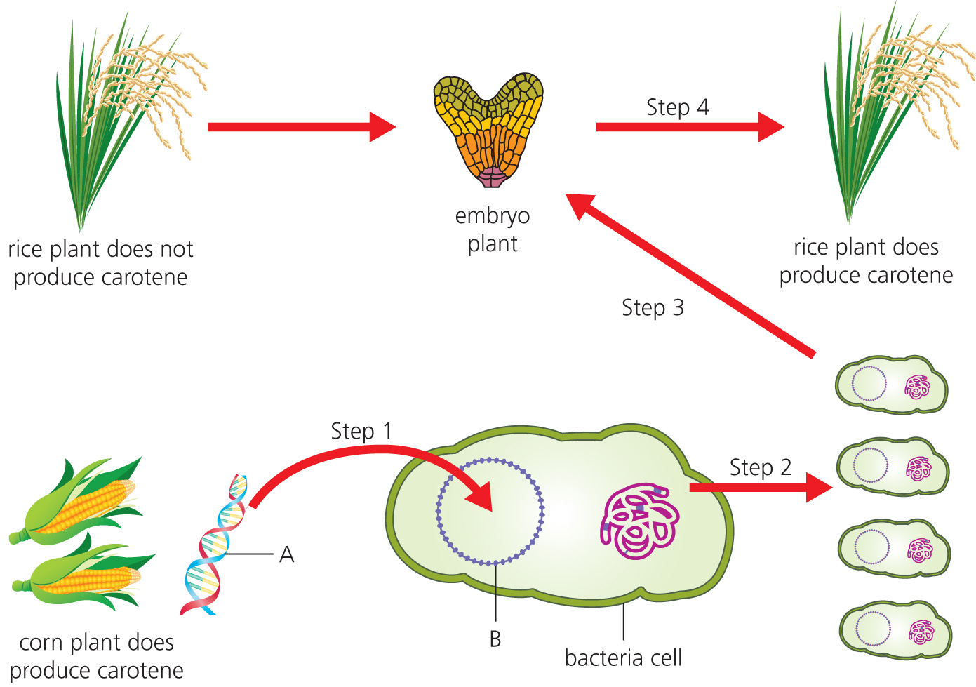

**a)** What is structure A? (1)

**b)** What is the significance of A in the whole engineering process? (2)

**c)** What is structure B? (1)

**d)** Describe what step 1 is showing. (2)

**e)** What process is taking place in step 2? (1)

**f)** Describe what step 3 is showing. (2)

**g)** The embryo plant is grown into mature rice plants in step 4. Some people are worried about growing crops that have been engineered in this way. Outline some of the concerns and benefits of genetically modified crops. (3)

**4** Cloning is a process of creating genetically identical copies of an organism.

**a)** What type of cell division results in clones? (1)

The flow diagram shows how Dolly the sheep was cloned. Parts of the diagram have been removed.

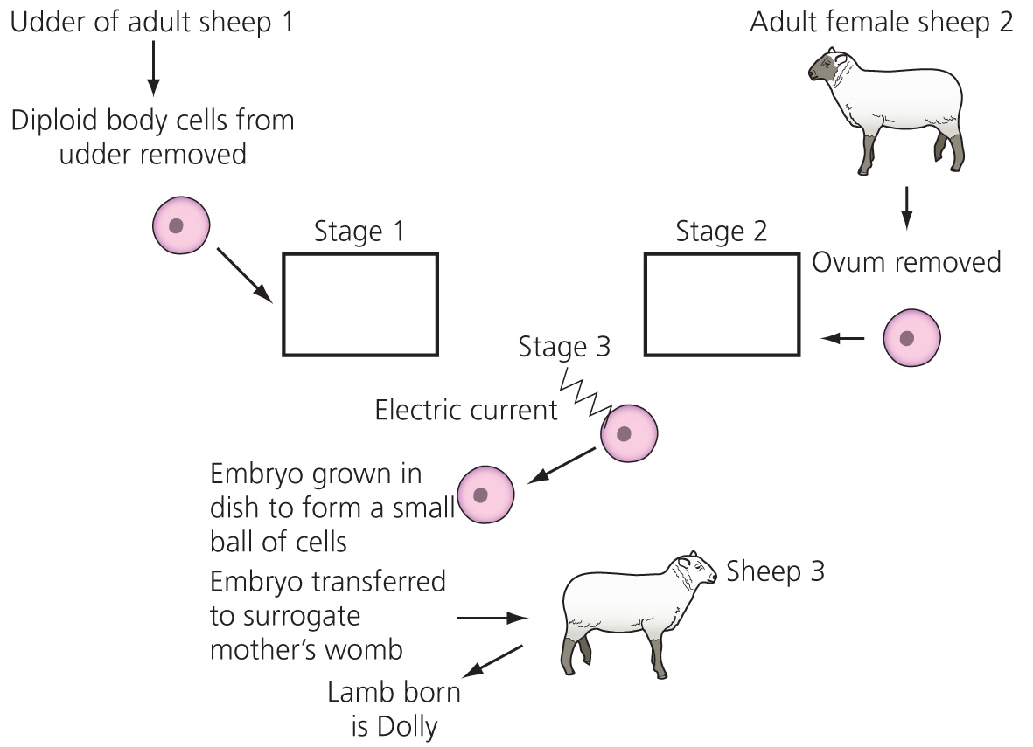

**b) i)** Stage 1 is the treatment of the diploid udder cell. What is happening to this  
cell in stage 1? (1)

**ii)** What is happening to the ovum in stage 2? (1)

**iii)** Why is an electric current applied in stage 3? (1)

**iv)** What is a surrogate mother (sheep 3)? (1)

**v)** To which sheep is Dolly genetically identical? (1)

**vi)** Explain your reasoning. (2)

**5** Many famous scientists have contributed to our knowledge of evolution, natural selection, classification and genetics. Match the scientist and their nationality with their most significant piece of work.

|  |  |  |
| --- | --- | --- |
| Scientist | Nationality | Contribution to science |
| Gregor Mendel | Czech | Naturalist. Developed a theory of evolution from observing a variety of organisms in the Far East and Amazon rainforest |
| Charles Darwin | English | Biologist. Believed that changes to an organism during their lifetime could be passed on to the next generation |
| Carl Linnaeus | Swedish | Scientist and monk. Established the rules for the inheritance of different characteristics |
| Alfred Russel Wallace | English | Botanist. Developed a system of classification and introduced a binomial naming system for organisms |
| Jean-Baptiste Lamark | French | Scientist. Developed a theory of evolution after a voyage around the world. Observations made in the Galapagos Islands |

(5)

**6** Evolution is the gradual change in a species over time. The fossil record provides evidence for the evolution of some species. However, the fossil record is not complete.

**a)** What is a fossil? (2)

**b)** Give two reasons why the fossil record is incomplete. (2)

**c)** What is meant by extinction? (1)

**7** The diagram shows the relationship between several similar families of mammal that have evolved from a common ancestor.

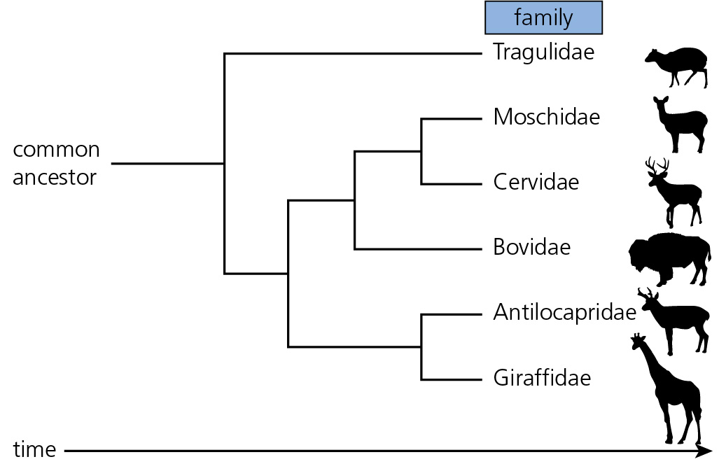

**a)** What is meant by a common ancestor? (1)

**b)** Which family is the most distantly related to the others? (1)

**c)** Animals are in one of the five Kingdoms. Name two other Kingdoms. (2)

**d)** Carl Woese proposed a new three domain classification system based on DNA and RNA evidence to replace the five kingdom model. What are these three domains? (3)

TOTAL = 50

**1** **a)** O (1)

**b)** As the alleles A, B and O; genes from parents. (1)

**c)** discontinuous (1)

**d)** bar chart (1)

**e)** continuous variation (1)

**f)** genes and the environment (2)

**g)** normal distribution; binomial distribution (1)

**2** **a)** transgenic (1)

**b)** genetic engineering (1)

**c)** genetically modified (1)

**d)** cloning (1)

**e)** plasmid (1)

**3** **a)** DNA (1)

**b)** This is the gene for carotene production in the corn. (2)

**c)** a plasmid; a loop of DNA (1)

**d)** The gene for carotene production is inserted into the plasmid; the plasmid is placed in the bacterial cell. (2)

**e)** cloning/asexual reproduction/ binary fission (1)

**f)** The modified bacterial cells/bacteria with the carotene gene; are inserted into the embryo plant. (2)

**g)** Concerns

* Some religions dictate that humans should not meddle with God’s organisms.
* Some people don’t believe genes should be transferred from one species to another.
* Some people think that modified genes might spread into the wild gene pool.

Benefits

* More food available for third world countries.
* Less spraying with herbicides/pesticides.
* Crops may be less susceptible to frost or drought or disease.
* Added vitamins enrich the food.

(at least one point from each section = 3)

**4** **a)** mitosis (1)

**b) i)** The nucleus is removed from the udder cell. (1)

**ii)** The ovum is being enucleated (having the nucleus removed); an empty egg cell is created. (1)

**iii)** To make the diploid nucleus enter the empty egg cell; to create the new egg cell with a diploid nucleus. (1)

**iv)** A sheep who is unrelated to either of the other sheep; her uterus is used to develop an embryo. (1)

**v)** sheep 1 (1)

**vi)** The genetic information comes from the nucleus; Sheep 1 supplied this nucleus; sheep 2 only supplied an empty egg; sheep 3 enabled the embryo to develop. (2)

**5**

|  |  |  |
| --- | --- | --- |
| Scientist | Nationality | Contribution to science |
| Gregor Mendel | Czech | Scientist and monk. Established the rules for inheritance of different characteristics |
| Charles Darwin | English | Scientist. Developed a theory of evolution after a voyage around the world. Observations made in the Galapagos Islands |
| Carl Linnaeus | Swedish | Botanist. Developed a system of classification and introduced a binomial naming system for organisms |
| Alfred Russel Wallace | English | Naturalist. Developed a theory of evolution from observing a variety of organisms in the Far East and Amazon rainforest |
| Jean-Baptiste Lamark | French | Biologist. Believed that changes to an organism during their lifetime could be passed on to the next generation |

(5)

**6** **a)** Fossils are ancient remains of plants and animals; that are preserved in rock. (2)

**b)** Not all organisms can be made into fossils; not all fossils have been found; some fossils have been damaged or are incomplete. (2)

**c)** Extinction is when a species completely dies out; there are no more living members on the planet. (1)

**7** **a)** An animal from which all the others evolved. (1)

**b)** Tragulidae (1)

**c)** Plant, Fungi, Protista, Bacteria (Prokaryote) any 2 (2)

**d)** Bacteria; Archaea; Eucarya (3)

TOTAL = 50